

Name: Kalyan Bandaru
Project Name: Amazon E-commerce
Date: 25 May, 2026

Objective Questions:

- What is the total number of attributes in the customer table?
A. Total number of attributes in the Customers table is 3.
They are: CustomerID, Customer Age, Customer Gender

- How will you get the “Customer’s” ages in the “Order” tables according to customer IDs?
- To get the customer’s age in to the Orders table from Customers table, I’ve followed the below steps:
Step 1:
- I’ve created a data modelling between Orders and Customers tables based on CustomerID column.
Step 2:
- Created a new column in Orders table named “CustomerAge” by using the DAX formula.
Customer’s Age = LOOKUPVALUE(Customers[CustomerAge], Customers[CustomerID], Orders[CustomerID])

- In analyzing the dataset with Power BI, ensure data cleaning to address inconsistencies and missing values before further analysis.
- Load the dataset into PowerBI Desktop, then click Transform Data to open Power Query Editor.
- Now use Column quality and Column distribution to view duplicates and nulls visually.
- Deleting duplicates, standardizing inconsistent text, validating relationship between orders and customers tables.
This ensured the dataset was complete, consistent, and ready for further insights.

- How can we calculate the total revenue generated by all the sales?
- To calculate the total revenue generated by all sales, create the below DAX formula,

Total Revenue = SUM(Orders[SalePrice])

The total revenue generated by all sales is $107.24M.

- What is the total number of unique customers who made purchases each year? Is there any increase in the number over the years?
- Total number of unique customers who made purchases each year can be identified by using a bar chart. X-axis is distinct count of CustomerID and Y-axis is year extracted from order date.
From 2015 to 2019, the total unique customers are around 17.5k. But in 2020, the total unique customers are 25.2k.
Therefore from 2015 to 2019, the increase in customers is linear but from 2019 to 2020 there is a significant increase.
- How can we determine the total number of unique products available in the company?
- The total number of unique products that are available in the company can be calculated by using the DAX formula below,

Total No.of Unique Products = DISTINCTCOUNT(Orders[Product])

There are total 44 unique products available in the company.

- What is the average number of days it takes for products to be delivered, get the metric for only the delivered orders.
To calculate the average number of days it takes for products to be delivered for only delivered products, I’ve followed the below approach.
Primarily I’ve created a Delivery Lead Time column by finding the number of days between order and delivery dates.

Delivery Lead Time = DATEDIFF(Orders[OrderDate], Orders[DeliveryDate], DAY)

Then I find the average delivery days for delivered products by the DAX formula,

Average Delivery Days = CALCULATE(AVERAGE(Orders[Delivery Lead Time]), Orders[Status] = “Delivered”)

Therefore, the average number of days it takes is 9.

- Which products, categories, and subcategories are the most popular?
- The most popular products, categories, and sub-categories based on the updated order quantity:

Most popular product:
- Avon Soft Must Eau de Toilette Spray – 50 ml is the most popular product with the highest order quantity of 14,444 sales.

Most popular product category:
- Health and beauty is the most popular product category with the highest order quantity of 199k sales.

Most popular product sub-category:
- Vitamins & Dietary sub-category is most popular product sub-category with the highest order quantity of 71k sales.

- Which products have seen an increase or decrease in sales over the year?
- Analysis of products trend over the year can be done by creating the line chart.
- X-axis : Total revenue
- Y-axis : Year extracted from the Order date
- This chart shows the revenue over year for each product.
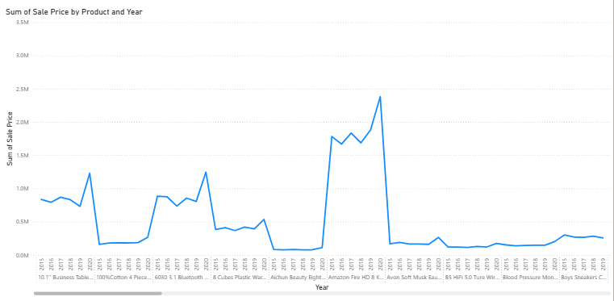

Observations:
- Sales trends are varying significantly across different products.
- Some products are products has linear growth, some gave quick hikes or slight downfall due to seasonal fluctuations or market spikes.

- While modelling the data relationships, what will be the type of relationship between the customer ID of Orders and customer tables?
- In data modelling, the relationship between CustomerID of Customer table and Orders table is One-to-Many relationship.

Because Customer table is consisting of each individual customer data, whereas Orders table consists of multiple orders data which can be placed multiple times by one customer only.

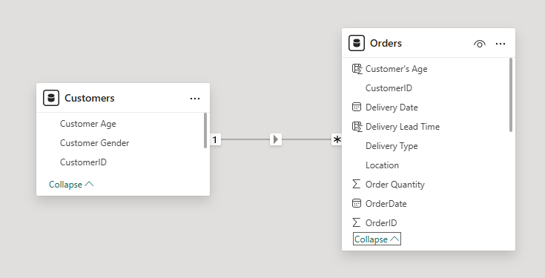

- How have you handled the null values in the data?
- While cleaning the data in PowerBI, I’ve followed the below steps:
- Firstly, I’ve identified and deleted 5 null columns in the Orders table.
- In Reason column all the cells for delivered orders are blank. I’ve replaced those blanks with “Delivered Successfully”.
- In Product Category column there is one blank. Replaced that blank with corresponding value for its sub-category.
- Replaced blank values with the corresponding ones in Unit Price column based on the similar products price.
- Replaced blanks with 0 in Order Quantity column.

- Were there any data format issues in the data, and if there were/are how you would handle them?
- While analysing and cleaning the data, I’ve made below changes:
- Standardized the column headers by adding the spaces, which improves consistency and readability.
- Removed few null columns and rows which doesn’t have any useful information.
- Blanks in various columns are replaced with corresponding values.
- Standardized the customer gender column by replacing single-word abbreviation.

- When we add a column in Power Query what’s the code that comes in M language in the formula bar? What do you know about M-query?
- When you add a column in Power Query, the M language code that appears in the formula bar is typically a “Table.AddColumn” function. This function adds a new column to your table with values defined by a formula you provide. The syntax for this function is as follows:

Table.AddColumn(Source, "NewColumnName", each [ExistingColumn] * 2)

In this example, Source is the name of the existing table, "NewColumnName" is the name you want to give to the new column, and each [ExistingColumn] * 2 is the formula where each value in the new column is calculated by doubling the value in ExistingColumn.

Regarding M-query, it’s the informal name for the Power Query M formula language. It’s a functional, case-sensitive language used in Power Query to perform data manipulation tasks. It’s designed to be intuitive and powerful, allowing you to perform complex transformations and data cleaning processes. M-query is integral to Power BI and other Microsoft services for managing and transforming data from various sources.

- Identify the top 5 most valuable customers using a composite score that combines three key metrics: (SQL)
    - Total Revenue (50% weight): The total amount of money spent by the customer.
    - Order Frequency (30% weight): The number of orders placed by the customer, indicating their loyalty and engagement.
    - Average Order Value (20% weight): The average value of each order placed by the customer, reflecting the typical transaction size.
- The top 5 most valuable customers are derived using a composite score which combines three key metrics like 50% of total revenue, 30% of order frequency, and 20% of average order value by using below SQL query.

with customer_data as (
select
customer_id,
sum(sale_price) as total_revenue,
count(order_id) as frequency,
round(avg(sale_price), 2) as average_order_value
from orders
group by customer_id
)
select
customer_id,
total_revenue,
frequency as order_frequency,
average_order_value,
round((total_revenue * 0.5 + frequency * 0.3 + average_order_value * 0.2), 2) as composite_score
from customer_data
order by composite_score desc
limit 5;

The table in the following picture shows the top 5 most valuable customers based on the composite score.

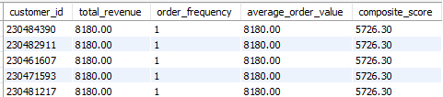

- Calculate the month-over-month growth rate in total revenue across the entire dataset. (SQL)
- The month-over-month growth rate in total revenue across all the months available in the dataset can be derived from the below SQL query.

with monthly_revenue as (
select
date_format(order_date, '%Y-%m') as months,
sum(sale_price) as total_revenue
from orders
group by months
order by months
),
monthly_revenue_comparision as (
select
months,
total_revenue as current_month_revenue,
coalesce(lag(total_revenue) over(order by months), 0) as previous_month_revenue
from monthly_revenue
)
select
months,
current_month_revenue as total_revenue,
coalesce(round(((current_month_revenue-previous_month_revenue)/previous_month_revenue) * 100, 2), 0) as growth_rate_percentage
from monthly_revenue_comparision
order by growth_rate_percentage desc;

From the SQL query, month-over-month growth rate is derived. Following picture consists of top 6 months which has highest growth rate.

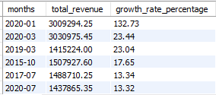

- Calculate the rolling 3-month average revenue for each product category. (SQL)
- The rolling 3 – month average revenue for each product category using SQL

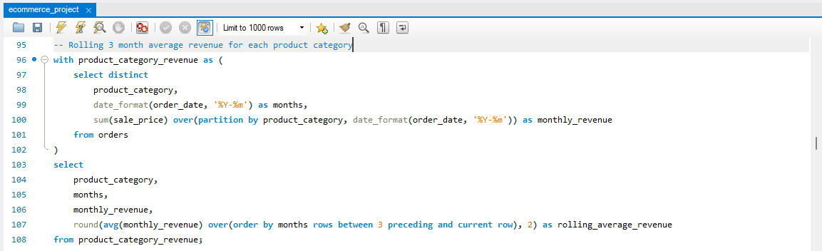
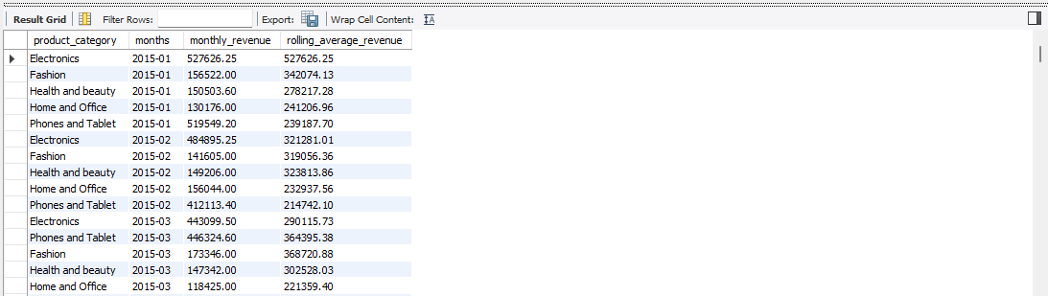

- Update the orders table to apply a 15% discount on the `Sale Price` for orders placed by customers who have made at least 10 orders. (SQL)
- The updated orders table by applying a 15% discount on the sale price for orders placed by customers who have made at least 10 orders using SQL.

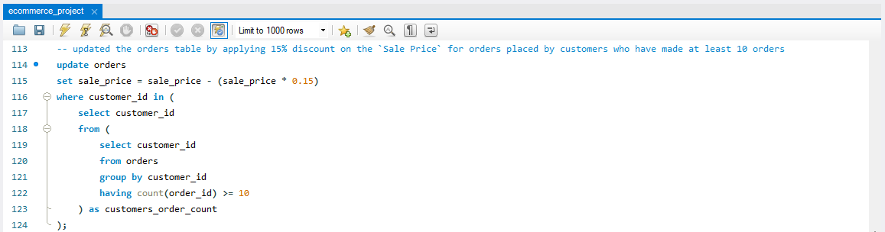

- Calculate the average number of days between consecutive orders for customers who have placed at least five orders. (SQL)
- The average number of days between consecutive orders for customers who have placed at least five orders using below SQL query,

with customers_order_dates as (
select
customer_id,
order_id,
order_date,
lead(order_date) over(partition by customer_id order by order_date) as next_order_date
from orders
)
select
customer_id,
avg(datediff(next_order_date, order_date)) as avg_days_between_orders
from customers_order_dates
where next_order_date is not null
group by customer_id
having count(order_id) >= 5;

- Identify customers who have generated revenue that is more than 30% higher than the average revenue per customer. (SQL)
- The customers who have generated revenue that is more than 30% higher than the average revenue per customer derived by using below SQL query,

select
customer_id,
sum(sale_price) as total_revenue
from orders
group by customer_id
having total_revenue > (select 1.3 * avg(sale_price) from orders);

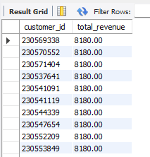

- Determine the top 3 product categories that have shown the highest increase in sales over the past year compared to the previous year. (SQL)
- To derive the top three product categories that have shown the highest increase in sales over the past year compared to the previous year I’ve used the below SQL query,

with past_year_sales as (
select
product_category,
sum(sale_price) as past_year_revenue
from orders
where year(order_date) = 2020
group by product_category
),
previous_year_sales as (
select
product_category,
sum(sale_price) as previous_year_revenue
from orders
where year(order_date) = 2019
group by product_category
),
revenue_difference_data as (
select
p1.product_category,
past_year_revenue as year_2020_revenue,
previous_year_revenue as year_2019_revenue,
past_year_revenue - previous_year_revenue as revenue_difference,
dense_rank() over(order by (past_year_revenue - previous_year_revenue) desc) as revenue_difference_rank
from past_year_sales p1
join previous_year_sales p2
on p1.product_category = p2.product_category
)
select
product_category,
year_2020_revenue,
year_2019_revenue,
revenue_difference as increase_in_sales
from revenue_difference_data
where revenue_difference_rank <= 3
order by increase_in_sales desc;

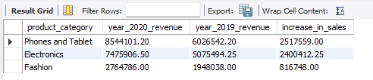

Subjective Question:

  - Explain the revenue breakdown by year and by-product. Evaluate how different products contribute to annual revenue and come up with suggestions to increase the sales of the low-selling items.

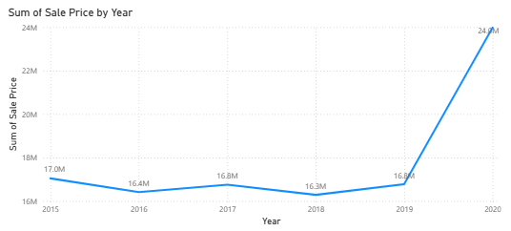
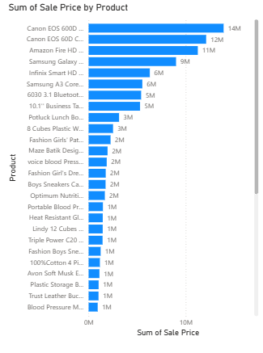

Suggestions to increase the sales of low selling items:
- More marketing should be there for low performing products. This helps those products to have more purchases.
- Pair up low performing products with similar high performing products. This technique increases the sales of low performing products.
- Detailed attention should be given to customer feedback for low performing products. As it helps to find the actual issue for that product of not having good sales.

  - How many products were returned? Use a DAX function to get this metric. Examine the possible reasons for returns and consider how this metric could indicate improvements in product descriptions or quality control.
- The below DAX function is used to get number of products were returned.

Returned Products Count = COUNTROWS(FILTER(Orders, Orders[Status] = “Returned”))

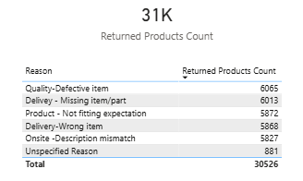
Improvements should be implemented to decrease product returns:
- Make sure all the product descripts have clear and accurate information about the product, because all the customers will decide after reading description.
- Everyday monitoring is needed for product descriptions to maintain them accurate, so that returning of products with this reason will be reduced.
- Most of the products are returned because of defective item and missing item, this clearly shows that poor maintenance of quality control team.
- A proper and detailed product maintenance training should be given to quality control team to make sure product is packed safely without missing any item.

  - Whenever a customer goes to Amazon, they’ll filter the most rated products to buy the better category. Can you verify this using any visualization or table that the ratings of products impact their sales value?
- Mostly all the customers whenever they open’s Amazon to buy a product, the first thing they’ll do is checking the ratings for that product.

It’s because customer’s who already bought those products provides rating and feedback based on their experience.

So, it clearly tells that higher rated products will be considered as best products.

I’ve created a below clustered column chart by aligning product categories to X-axis, total revenue generated to Y-axis, and ratings as legend.

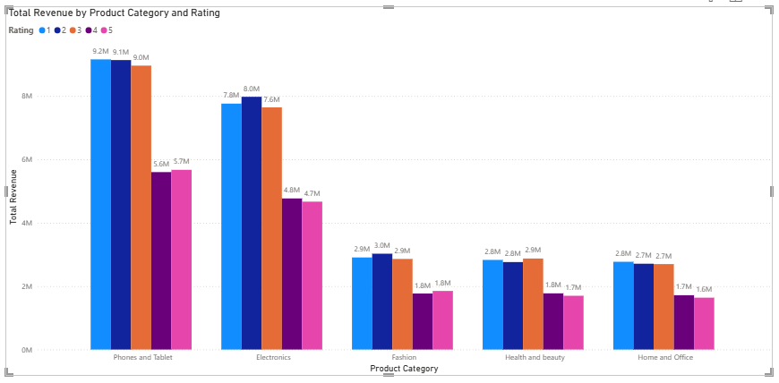

Observations from chart:
- The highest revenue generated from the products having ratings 1, 2, and 3.
- Products with rating 4 and 5 have generated average revenue.
- However, ratings alone cannot show the impact on sales.
- Factors like number of orders, price, product quality, etc will also have high impact on sales of the products.
- For all the low performing products strategic marketing efforts should be done to increase the sales.

  - Investigate how revenue distribution varies across different locations. Explore which geographical areas contribute most to sales and consider the strategic implications for regional marketing and distribution efforts. How might location-based trends inform the company's market segmentation and resource allocation approach?
- To find out how revenue distribution varies across different locations, I’ve used the following map chart by plotting the total revenue with bubble size.

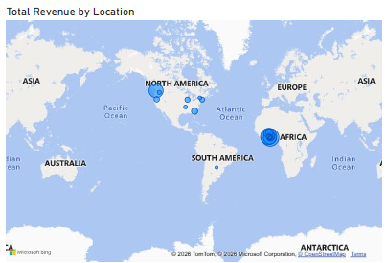

Analysis and Strategic Implementations:
- Identify regions with the highest revenue (e.g., “Greater Accra” in this case).
- Consider other locations that contribute significantly.
- Use location-based trends to segment your market effectively.
- Target high-revenue areas with tailored marketing campaigns.
- Understand local preferences and adapt product offerings.
Resource Allocation:
- Allocate resources (sales teams, inventory, marketing budget) based on revenue-generating regions.
- Prioritize expansion efforts in promising locations.
- Optimize supply chain and distribution networks for efficient delivery.
Competitive Advantage and Risk Mitigation:
- Leverage insights to outperform competitors in specific regions.
- Identify untapped markets for potential growth.
- Diversify across locations to reduce dependency on any single market.
- Monitor revenue fluctuations and respond proactively.
Conclusion:
- Location-based trends inform critical decisions, impacting market segmentation, resource allocation, and overall business strategy.

  - Determine which month could benefit from enhanced promotional offers to boost sales. Can you suggest some targeted marketing strategies here?
- I’ve used the line chart by aligning total revenue generated in X-axis and months to Y-axis to determine which month could be benefited from enhancing promotional offers to boost sales.

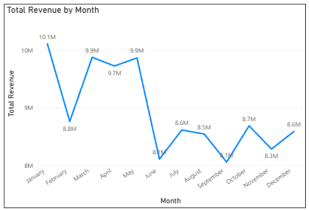

Observations:
- Form the line chart it’s clearly shows that from January to May the sales are doing great by generating average revenue of 9.6M.
- But from June to December the average revenue generated is 8.4M.
- The least revenue generated months are June and September.
Suggestions:
- Promote seasonal products to increase the sales in least performing months.
- Offer best discounts on most selling items in those months to improve sales.
- Conduct mega sales by offering best discounts on high priced products.
- Marketing efforts should be more in these months to attract customers towards the mega sales, discounts, etc.
- Run time-bound discounts to improve the sales.

  - Identify which products may require increased marketing efforts. Which items have high prices yet underperform in sales?
- The products in the below table are having high prices i.e., greater than unit price of 500, but still underperforming in terms of number of orders and customer average ratings.

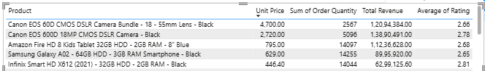

The above products are under performing compared to other products in terms of customer ratings which is below 3, number of units sold even with high prices.

These products need much more marketing efforts to boost the sales and revenue.

Suggestions:
- Customer’s dissatisfaction clearly tells that the products are over priced or products displaying is not effective.
- Better product positioning is required.
- Product images and descriptions should be clear and factful which helps to improve customer satisfaction.
- Attach related products like combos where a customer can order two useful products in single shot.
- Strong promotions like influence marketing, campaigns, and limited time-bound discounts will help to increase the sales.

  - Assess which products should have discounts. How can targeted incentives drive sales and customer loyalty for specific products?
- The products which have high price and sales are less, those products should have discounts.

The table has the list of products which have high price and low sales.


As observed in the table, Canon cameras are the highest priced products with lowest sales. To boost the sales of these products strategic discounts should be given on these products.

Suggestions:
Identify you target audience:
- Understand your target customers by segmenting based on demographics purchase history, preferences, and purchase history.
- Tailor incentives to specific group of customers who are likely to purchase the product.
Personalized offers:
- Create customized incentives that resonate with each customer segment.
- Examples include exclusive discounts, rewards points, freebies, or special promotions specifically targeted at certain products.
- Personalization enhances the relevance of the incentive and makes customers feel valued.
Promote scarcity and urgency:
- Use targeted incentives to create a sense of scarcity and urgency around the product.
- Limited-time offers, flash sales, or exclusive access to new products can motivate customers to make a purchase quickly before missing out on the deal.
Implement loyalty programs:
- Set up loyalty programs that offer rewards or incentives for repeat purchases of specific products.
- Encourage customer loyalty by providing additional benefits for consistently choosing your brand.
Leverage referral programs:
- Encourage customers to refer their friends and family to purchase the targeted product.
- Offer incentives such as discounts, credits, or freebies for both the referrer and the new customer.

  - Come up with a loyalty program to benefit the company’s customers. From the available lot of customers come up with strategies to bucket them and provide benefits under different loyalty programs.
- A well-designed customer loyalty program can significantly impact customer retention, drive repeat business, and enhance brand loyalty. In this proposal, we’ll outline strategies for creating a successful loyalty program and customizing it to benefit different customer segments.

Understanding customers:
- Start by analysing existing customer data to identify key segments. Consider factors such as demographics, behaviour, and preferences. Segmentation allows you to tailor incentives effectively.
Segmentation strategies:
- Tiered strategy: Bronze/Silver/Gold with escalating offers.
- Behaviour based: Reward frequent purchases, referrals, and social media engagement.
- Demographic: Tailor offers by age, interest, and profession.
Program elements:
- Reward points: Earn per purchase, redeem for discounts.
- Discounts/offers: Regular deals, early sale access, exclusive promotions.
- Personalized rewards: Based on favourites or special occasions.
- VIP treatment: Priority support, personal assistance, exclusive events.
- Referral bonus: Rewards for successful referrals.
Communication:
- Notify via email, SMS, and social media.
Feedback & metrics:
- Collect feedback from program participants regularly.
- Monitor program performance metrics (e.g., retention rates, repeat purchases, customer lifetime value).
- Adapt the program based on insights and customer preferences.
Example benefits:
- Bronze: Points per purchase, birthday discount.
- Silver: Faster point accrual, early sale access.
- Gold: Personal shopper, VIP event invites, surprise gifts.
Launch & promotion:
- Announce the loyalty program through various channels (website, social media, in-store).
- Encourage sign-ups with an initial bonus (e.g., welcome points).

  - Using the DAX functions Calculate and a row iteration DAX function calculate the total sales for the Product Category “Fashion” and delivery type “Shipped from Abroad”. What are the other types of DAX functions you have used in the project?
- In order to calculate the total sales for the product category “Fashion” and delivery type “Shipped from Abroad” we have to use following DAX measure.

Total sales for Fashion shipped from abroad = CALCULATE(SUMX(Orders, Orders[Sale Price]), Orders[Product Category]="Fashion", Orders[Delivery Type]="Shipped from Abroad")

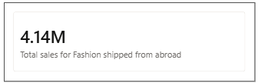

By using the card visualization, we can see that the total sales for Fashion category shipped from abroad is 4.14M.
  - Wait Times Correlated with Demographics and Care: Explore how average wait times vary across different product categories to optimize scheduling and staffing.
- The following visualization shows negative correlations using a scatter plot as the trend line in scatter plot is declining slightly.
Visualization:
- Utilize a scatter plot to analyze average wait times over time.
- Place months or years (according to need) from the Order Date on the x-axis.
- Represent the average wait time on the y-axis.
- Inserted a trendline, where the trend line is slightly declining which shows negative correlation.

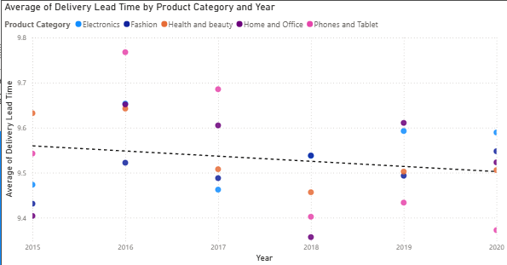

Analysis:
- Identify trends in average wait times for each product category.
- Look for clusters of data points indicating positive correlations between wait times and specific months or years.

Optimization Strategies:
Staffing Adjustments:
- Allocate more staff during peak wait times.
- Ensure adequate coverage for high-demand periods.

Scheduling Optimization:
- Schedule breaks and shifts strategically to manage wait times.
- Consider staggered shifts to handle fluctuations.

Product Category Insights:
- Identify which product categories contribute most to wait times.
- Prioritize resources accordingly.

Customer Communication:
- Set realistic expectations for wait times.
- Provide estimated wait times during interactions.

Process Improvements:
- Streamline processes to reduce wait times.
- Optimize call routing and handling procedures.

Resource Allocation Approach:
- Allocate staffing resources based on the insights from the analysis.
- Adjust schedules and staffing levels as needed.

Conclusion:
- By understanding positive correlations between wait time variations across product categories, you can enhance customer experience and operational efficiency.
  - Explore if there is any relationship between the Delivery type and waiting time between ordering and receiving an item.
- This analysis explores the relationship between delivery type and the waiting time between ordering and receiving an item. By understanding this relationship, we can optimize scheduling and staffing for better customer experience.

Visualization:
- We have used a bar chart to compare average waiting times based on different delivery types.
- The average waiting time for products which are shipped form abroad is approximately 15.0 days.
- The average waiting time for products which has standard delivery is approximately 10.0 days.
- The average waiting time products of express delivery is approximately 3.5 days.

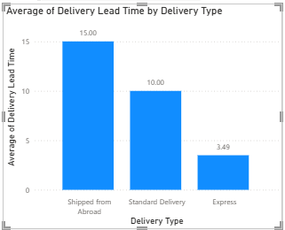

Analysis:
- The “Express” delivery type has the shortest average waiting time, making it ideal for customers who need quick delivery.
- “Standard Delivery” falls in the middle, providing a balance between speed and cost.
- “Shipped from Abroad” has the longest waiting time, likely due to international shipping.

Resource Allocation:
- Allocate resources based on delivery type trends.
- Staff adequately during peak delivery times for each type.

Customer Expectations:
- Set realistic delivery expectations based on the chosen delivery type.
- Communicate estimated wait times to customers during the ordering process.

Hence the conclusion is, understanding delivery time variations helps enhance customer satisfaction and operational efficiency. Choose the right delivery type based on customer needs and business priorities.

  - Is there any relationship between shipping charges and product type?
- Yes, there is a relationship between shipping charges and product type but there is no use of considering this relationship because the difference is very slight. To identify the relationship below pie chart will help.

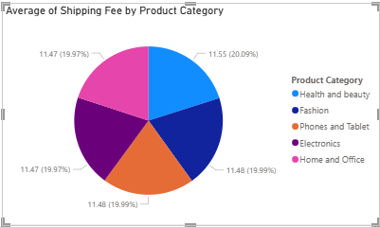

From the pie chart we can observe that Health and beauty category has highest average shipping fee and Home and office category has lowest shipping fee.

In the same way below line chart will help to understand the relationship between shipping fee and delivery type.

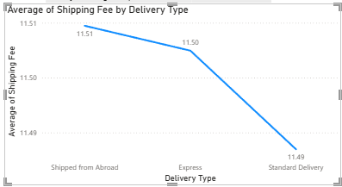

From the above line chart we can observe that the products shipped from abroad has highest shipping fee and the products with standard delivery has lowest shipping fee.

  - Come up with strategies to decrease the low rating orders after analyzing different factors like waiting time, shipping type, unit price, etc.
- The following strategies will help to decrease low-rating orders based on the analysis of various factors such as waiting time, shipping type, and unit price.

Factors to analyse:
Waiting Time:
- Investigate delays in order processing and delivery.
- Identify bottlenecks and streamline the fulfilment process.
- Set realistic delivery expectations for customers.

Shipping Type:
- Evaluate the impact of different shipping methods (e.g., standard, express, same-day).
- Optimize logistics based on customer preferences and cost-effectiveness.

Unit Price:
- Assess the relationship between product pricing and customer satisfaction.
- Consider pricing adjustments if high-priced items receive low ratings.

Strategies to Decrease Low-Rating Orders:
Quality Control:
- Implement rigorous quality checks before shipping.
- Ensure accurate product descriptions and images.

Customer Communication:
- Provide real-time order updates.
- Address customer inquiries promptly.

Feedback Loop:
- Encourage customers to leave reviews.
- Use feedback to improve processes.

Staff Training:
- Train staff on order accuracy and customer service.
- Empower them to handle customer concerns effectively.

Returns Management:
- Simplify return processes.
- Analyse return reasons to identify patterns.

Supply Chain Optimization:
- Maintain optimal inventory levels.
- Optimize supplier relationships.

Data-Driven Decisions:
- Continuously monitor metrics (e.g., Order Defect Rate, customer feedback).
- Use insights to refine strategies.

Resource Allocation Approach:
- Allocate resources (staff, technology, inventory) based on the identified strategies.
- Prioritize areas with the highest impact on customer satisfaction.

  - Using the time intelligence DAX function, create a table to compare each month’s sales with the previous year’s same month’s total sales. So there will be four columns in the output year, month, total sales, previous_years_sales.
- The below time intelligence DAX function calculates the total revenue for the same period last year considering the context of Orders table and Order date column.

It used the SAMEPERIODLASTYEAR function to get the sales from the previous year.

The ALLEXCEPT function ensures that only the Order Date context is preserved while removing other filters.

Previous Year's Same Month Sale = CALCULATE([Total Revenue], SAMEPERIODLASTYEAR(Orders[Order Date]), ALLEXCEPT(Orders, Orders[Order Date]))
Visualization:
- The answer suggests visualizing this data using a table. Unfortunately, there is no screenshot provided, so we cannot directly assess the visualization.
- However, creating a table with columns for year, month, total sales, and previous year’s sales would indeed be an appropriate way to present this information.

Analysis:
- The analysis states that the revenue of the company is increasing every year. However, without the actual data or visualization, we cannot verify this claim.
- To validate this statement, we would need to compare the total sales for each month across different years.

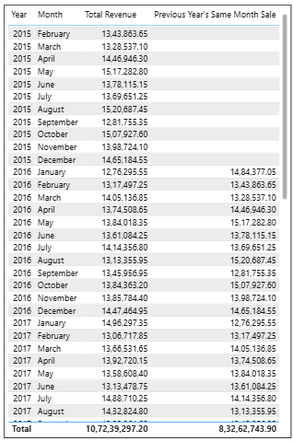

  - What do you understand by PowerBI gateway? What are its use cases?
- Power BI Gateway is a crucial component within the Power BI ecosystem, the Power BI Gateway facilitates secure data flow between on-premises data sources and the cloud-based Power BI Service. Its primary purpose is to keep your Power BI reports and dashboards up-to-date by connecting to data sources that aren’t directly accessible from the cloud.

Here are the two types of Power BI Gateway:
- Standard Mode: Typically used at the enterprise level, the standard mode serves multiple users and provides access control per data source.
- Personal Mode: Designed for individual use, the personal mode runs as a single user with personalized credentials.

Now, let’s explore the key use cases for Power BI Gateway:
- Data Refresh: Ensures that reports and dashboards in Power BI stay current by fetching the latest data from internal databases, files, or other on-premises sources.
- Data Security and Compliance: Organizations can maintain data control by using the gateway to keep sensitive information within their network perimeter. This addresses security and compliance requirements, especially for data that cannot be stored or processed in the cloud due to regulations or organizational policies.
- Live Connection: Power BI Gateway enables real-time connections to on-premises data sources. Users can create reports and dashboards in Power BI Service that directly link to on-premises data without storing it in the cloud.
- Diverse Data Source Support: Power BI Gateway accommodates various data sources, including SQL Server, SharePoint, Oracle, SAP HANA, Teradata, and more.

  - How would you approach this problem, if the objective and subjective questions weren't given?
- Below I’ve mentioned a clear and systematic approach for Amazon Sales Problem if the objective and subjective questions weren’t given.

Initial Data Exploration:
- Begin by exploring the dataset to understand its structure, including available tables, columns, and relationships.
- Identify key variables such as product information, customer details, and order dates.

Define Objectives:
- Clarify the goals and objectives of the analysis.
- Understand business needs, identify key performance indicators (KPIs), and determine areas of focus (e.g., sales performance, customer behaviour, or product trends).

Data Cleaning and Preparation:
- Clean the data to address inconsistencies, missing values, and data format issues.

Tasks include:
- Removing duplicate records.
- Standardizing data formats.
- Handling null values appropriately.
- Ensuring data integrity and consistency.

Statistical Analysis and Modelling:
- Perform statistical analysis and modelling to uncover relationships, patterns, or correlations in the data.

Visualization and Reporting:
- Create visualizations using charts, graphs, and dashboards to communicate insights effectively.

By following all the above steps, we can systematically approach the Amazon sales problem and derive meaningful insights.

